Chapter 5, Solution 28.
10 V

+
−
10 kΩ
50 kΩ
−
+
v_{o}
20 kΩ
v₁
v_{a}

At node 1, 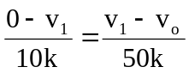

But v₁ = 10V,

–5v₁ = v₁ – v_{o}, leads to v_{o} = 6v₁ = 60V

Alternatively, viewed as a noninverting amplifier,

v_{o} = (1 + (50/10)) (10V) = 60V

i_{o} = v_{o}/(20k) = 60/(20k) = 3 mA.

